**UNDER EMBARGO UNTIL 00:01 (GMT), 19 November 2024**

**The Missing link: iFi Audio Unveils the GO link Max**

***Southport, UK:*** iFi Audio, a trailblazer in high-fidelity audio components, proudly introduces its latest innovation: the GO link Max. The GO link Max features improvements in output power to drive demanding headphones, a 4.4mm balanced headphone output, clearer audio thanks to vastly reduced distortion, and a more engaging and wider dynamic range.

Looking for the perfect solution to enhance your music on the go? This ultra-portable DAC is designed to make your music sound clearer, richer, and more immersive than ever before. Whether you're a casual listener or an audiophile, the GO link Max will transform the way you hear your favourite tracks, bringing out every detail and making it feel like you're hearing them again for the very first time.

**Key Features:**

* **Up to 241mW of power for louder, clearer sound:** Delivers up to 241mW of output power – nearly five times that of a standard MacBook Pro. This extra power ensures your music plays louder and clearer, even with high-end, power-hungry headphones.
* **Balanced circuitry for reduced noise and better audio separation:** Features 4.4 balanced connection to unlock balanced sound. Designed with balanced audio circuitry, this device significantly reduces noise and interference. It provides better separation between the left and right channels, giving you a more immersive listening experience with precise instrument and vocal positioning.
* **THD Compensation for purer, less distorted sound:** Advanced THD Compensation technology minimises total harmonic distortion, giving you cleaner, purer audio. This means fewer unwanted distortions and a more accurate representation of your music.
* **Dual DAC setup with jitter elimination for precise, clear audio:** With its dual ES9219 DACs and Time Domain Jitter Elimination, it ensures incredibly precise audio conversion. This setup reduces timing errors, delivering ultra-clear sound with incredible detail.
* **Dynamic Range Enhancement for more exciting music:** Boosting the dynamic range by an additional +6dB, making the loudest moments louder and the quietest moments clearer, giving your music more depth, excitement, and emotional impact.
* **Supports hi-res audio formats like PCM 384kHz and DSD 256:** For those who appreciate high-fidelity sound, it supports hi-res audio formats like PCM 384kHz and DSD 256. This ensures your music is delivered with the highest possible quality, revealing every nuance of your favourite tracks.

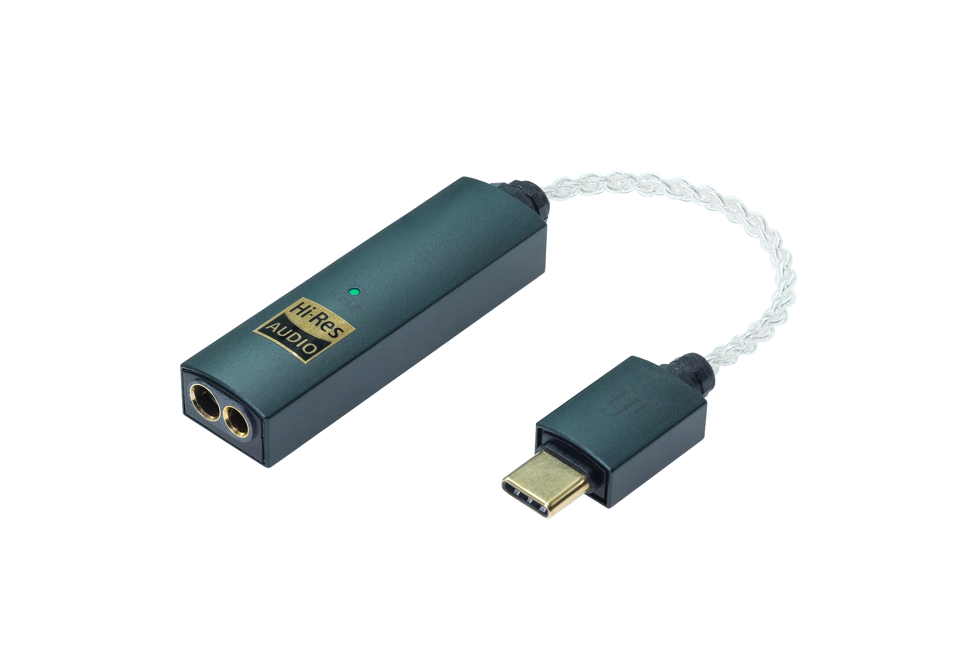

**Big Sound in a Small Package**

Despite its compact size, the GO link Max delivers a huge audio upgrade compared to its worthy predecessor. With up to 241mW of output power – nearly five times more than a MacBook Pro* – it drives demanding headphones with ease, making your music sound louder, clearer, and more powerful wherever you go.

*\*Calculated at 32 ohms RMS using MacBook Pro’s stated headphone output voltage.*

**Balanced Dual DAC for Perfect Clarity**

The GO link MAX features a dual DAC setup with two ES9219 DAC chips, delivering enhanced audio performance compared to the original GO link. This configuration boosts the signal-to-noise ratio (SNR) from 125dBA (S-Balanced) to an impressive 130dBA (Balanced), resulting in cleaner, more detailed sound with minimal background noise. The dual DACs also provide better channel separation, allowing for a wider soundstage and more precise left-right distinction. Distortion is significantly reduced, with the THD+N improving from <0.004% (S-Balanced) in the original GO link to <0.0015% (S-Balanced) in the GO link MAX, ensuring ultra-low distortion for pristine sound.

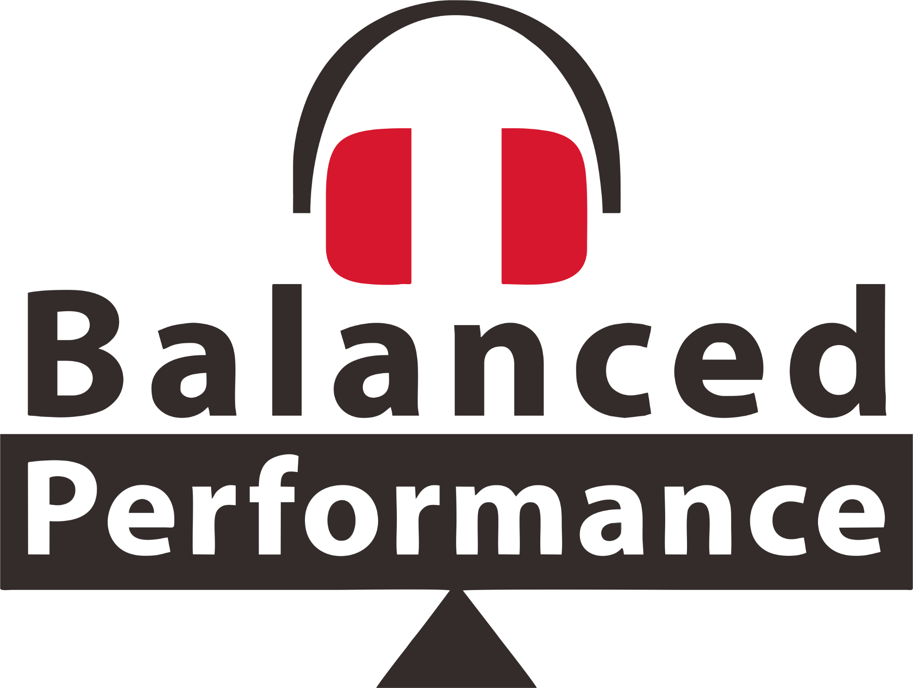The Dual DAC setup also enhances the balanced audio output, minimising interference and maximising the signal-to-noise ratio. This results in clearer, more refined sound, leading to a richer and more immersive listening experience, making the GO link MAX a standout choice for ultraportable, high-quality audio.

The GO link Max is built with a 4.4mm balanced headphone output, helping listeners unlock the benefits of ultra-clear, precise balanced sound. With balanced audio, there is significantly

less risk of unwanted noise or interference disrupting the signal, as it uses separate pathways for the left and right channels. This results in cleaner audio with improved clarity, and reduced distortion.

The sound separation between layers is more pronounced, significantly improving the soundstage and providing a wider, more immersive listening experience. The balanced output allows listeners to enjoy a sound full of musicality and emotion, delivering audio that is vibrant, rich in detail, and full of energy.

**Next-Level Sound Quality**

iFi has unlocked advanced technology to significantly minimise Total Harmonic Distortion (THD) in the GO link Max. Harmonic distortion occurs when non-linearities in the digital-to-analogue conversion process introduce unwanted frequencies (harmonics) that distort the original audio signal.

The THD compensation within the DACs detect these harmonics and apply corrective measures to reduce their impact, resulting in cleaner, more accurate sound. This advanced technology effectively targets 2nd and 3rd harmonics, which commonly distort audio, ensuring a smoother listening experience. It also enhances the natural benefits of a balanced DAC configuration, where harmonic distortion is already minimal.

The inclusion of THD compensation brings substantial benefits to audio quality. By minimising harmonic distortion, the GO link Max delivers clearer, more transparent sound with less colouration. Subtle musical details, often masked by distortion, become more discernible, and the overall sound reproduction feels more natural. Whether listening to high-resolution audio or immersive movie soundtracks, the reduced distortion ensures a smoother, more enjoyable experience.

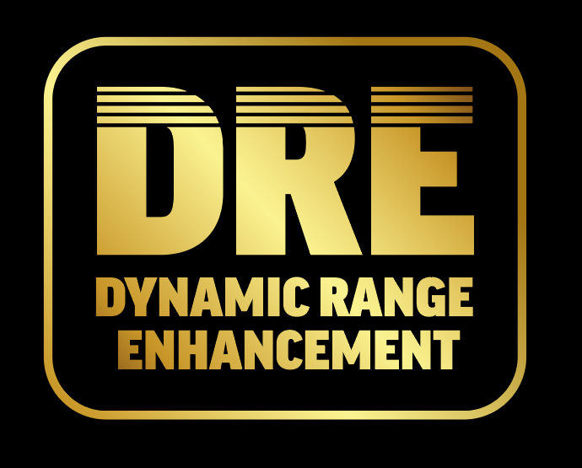

The GO link Max features Dynamic Range Enhancement (DRE), unlocking an additional +6dB of dynamic range to enhance the contrast between the loudest and quietest sounds. This technology breathes life into your audio by delivering exhilarating highs and deep, resonant lows, ensuring that every note is dynamic and clear. Whether you're listening to music, movies, or games, DRE creates a broader spectrum of sound, making crescendos

more impactful and subtle fades more delicate, resulting in a heightened sense of depth and realism.

**Crystal-Clear Sound & Precision**

Thanks to its advanced ‘Quad DAC+’ and ‘Time Domain Jitter Eliminator’ technologies, the GO link Max delivers ultra-low distortion and outstanding clarity. The ‘Quad DAC+’ architecture enhances dynamic range, improves signal-to-noise ratio (SNR), and ensures cleaner, more detailed sound reproduction.

This groundbreaking level of sonic purity is further refined by iFi’s dedicated GMT clock circuitry, featuring a specialised crystal oscillator to ensure precise musical timing and smooth, distortion-free playback. Together, these technologies create a vibrant, crystal-clear soundstage, providing exceptional musical timing.

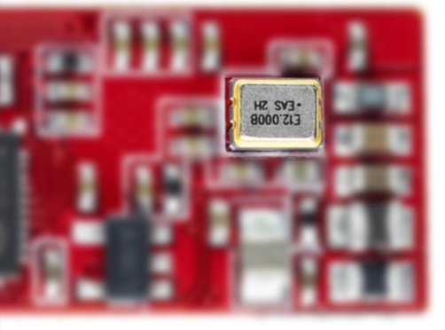

Every note, instrument, and vocal is rendered with pinpoint accuracy, allowing listeners to experience their music with enhanced clarity and precision, free from the subtle distortions that can otherwise impact sound quality.

**Do the Twist(ed Cables)**

The GO link Max features a silver-plated copper cable with individual polymer insulation in a helix design to virtually eliminate any interference.

Unlike standard, single wired audio cables which are often affected by electrical interference from nearby electrical sources, the twisted cable on the GO link Max reduces inductance and capacitance and rejects any outside noise, due to good shielding. This leaves the listener with clearer, uninterrupted sound, helping you get completely lost in your music.

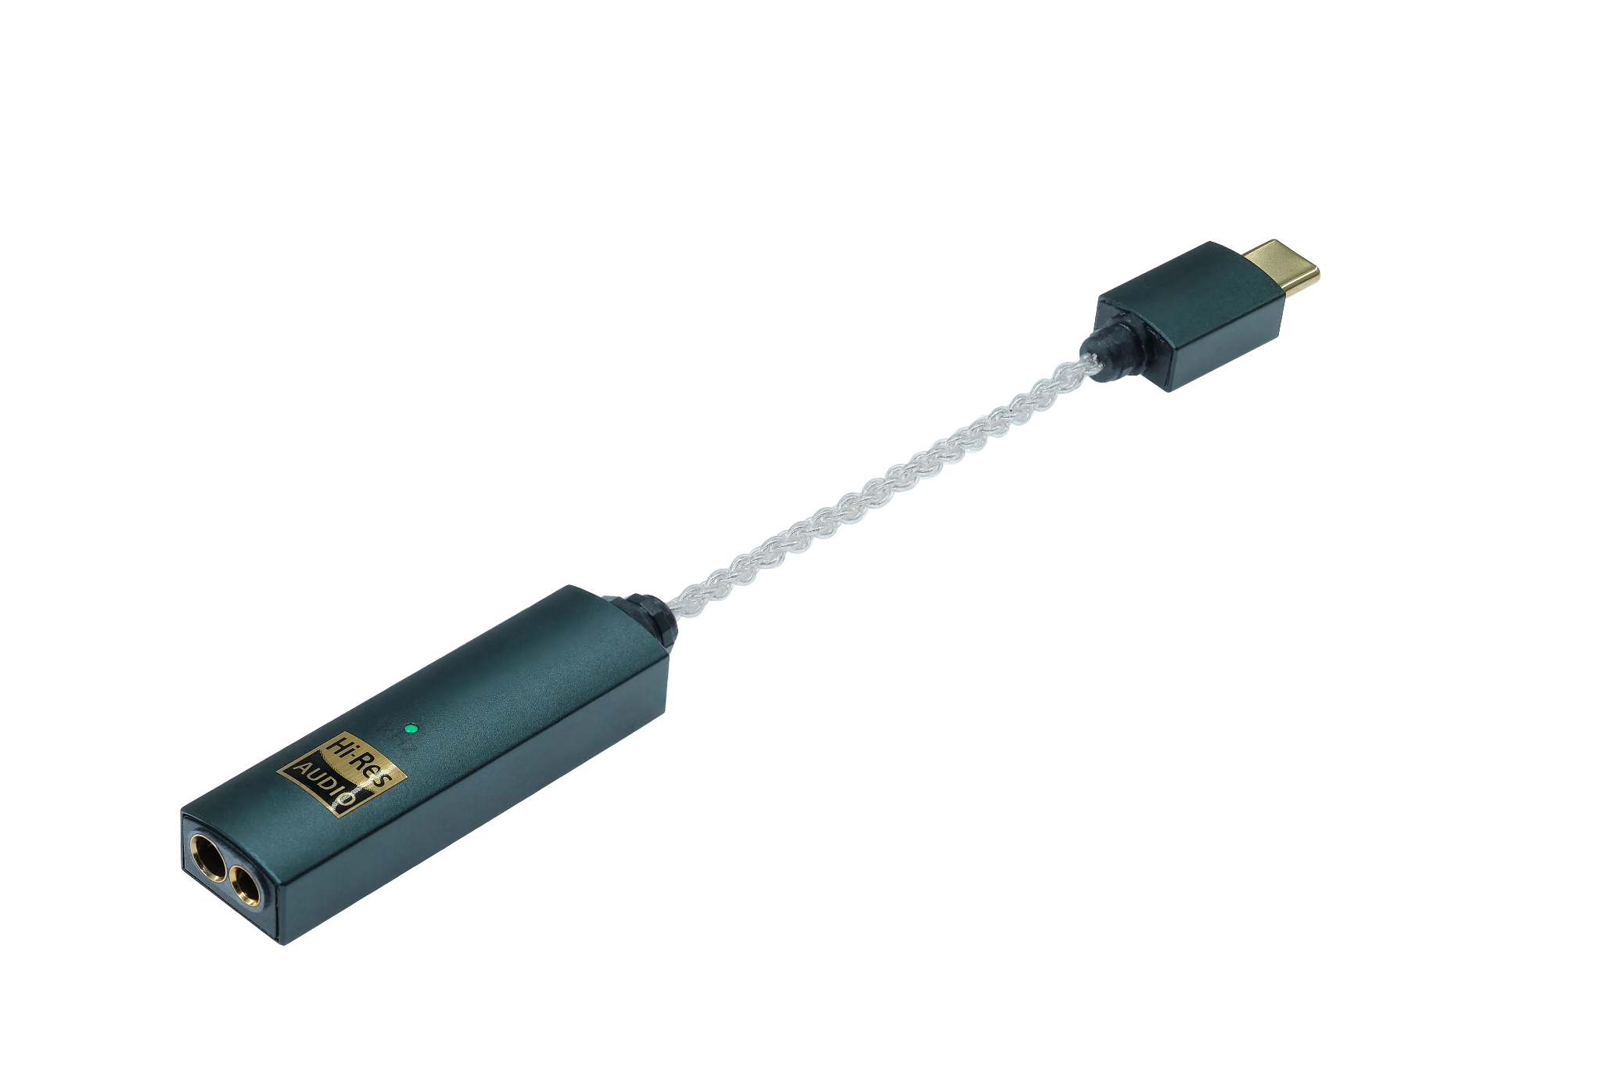

**Easy, High-Quality Volume Control**

The GO link Max uses a hardware-based volume control to ensure changes in volume do not affect the quality of the sound.

Many audio products at this price point adjust volume by software by decreasing data sent to the DAC, which strips away the details and nuances in the music delivering an overall lower quality sound. Hardware-based adjustments keep the quality consistently high when you either need to turn up the volume during a busy train or plane journey, or equally when a lower volume level is needed to help you concentrate while studying or working.

**GO link Max vs GO link:**

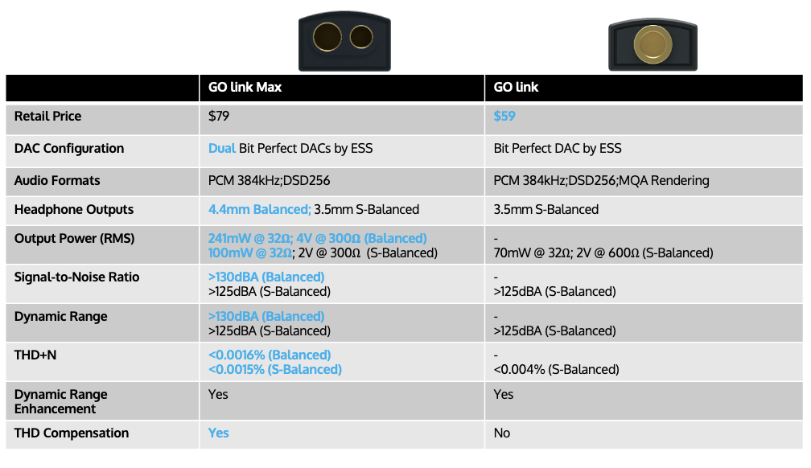

**Pricing & Availability**

The iFi GO link Max is available to purchase from ifi-audio.com and selected retailers for $79 USD.  
  
**US Press Contact**

Hummingbird Media  
Shelby Coppola  
[shelby@hummingbirdmedia.com](mailto:shelby@hummingbirdmedia.com)

**About iFi**

iFi is the sister-brand of Abbingdon Music Research (AMR) and is headquartered in Southport, UK. The two brands respectively design and manufacture portable, desktop and lifestyle audio products and high-end hi-fi components. Combined in-house hardware and software development teams and a ‘music first’ approach enable iFi and AMR to create advanced audio products that deliver new levels of design, functionality and performance at their respective price points. Since iFi’s formation in 2012, its products have earned many awards around the world, helping it to become one of the fastest-growing brands in its field.

[www.ifi-audio.com](http://www.ifi-audio.com)

**General Specifications**



